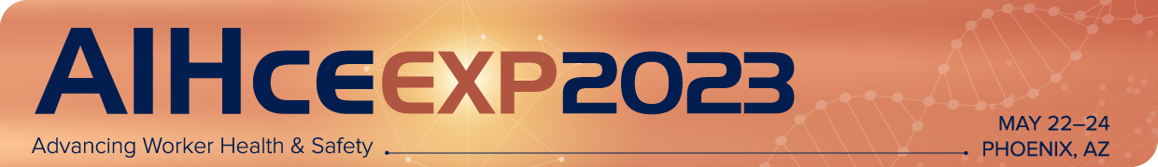
Pop-Up Session Presentation
Proposal Worksheet
Please note: This document is to be used to prepare your submission data only. All submissions must be entered in the online submission portal: https://ww2.aievolution.com/aih2301/

Pop-Up Session (25-minute) – A short and interactive session designed to deliver bitesize, timely, targeted learning. These sessions are held outside of session rooms, in an open area of the convention center. Pop-up sessions can involve a single presenter, or up to a maximum of three presenters.

*Title
The title should be clear and concise. *If selected, the title you provide will be listed online and in printed materials. It may be edited for marketing purposes. Limit of 500 characters.

*Presenters
Click below to add the presenter* and, any co-presenters.
Please note: you may have a maximum of two (2) co-presenters, for a total of three (3) presenters for the 25-minute session. A biography is required for all presenters. If you do not have the biography information, you can add a placeholder. If accepted each presenter will have the opportunity to update the biography and add a headshot.
*Required

A Presenter must be defined for this proposal. Are you the Presenter?

Pop-up Presenter
Presenter Name
Edit | Remove
Biographical Information (Completed)

Pop-up Co-Presenter(s)
No Pop-up Co-Presenters have been submitted.

*Description
Provide a clear summary of the information to be presented. Make specific note of pertinent tools or resources that will be shared. *If selected, the description you provide will be listed online and may be edited for marketing purposes. (Limit 1500 Characters)

*Practical Application
How will this help industrial/occupational hygiene professionals do their job better?

*Topics
Please select one primary topic area (required) and up to two secondary topics (optional). This information will be used to place sessions into appropriate tracks, for scheduling purposes and marketing.
Complete topic list can be found here: https://aiha-assets.sfo2.digitaloceanspaces.com/AIHA/aihce/2022/2022-Topics.pdf

* Primary Topic (Choose 1)

Secondary Topics (Choose Up To 2)

*Additional Details

*Pop-up Education Proposal Agreement

Please read the following and check the acknowledgement at the bottom.
- All proposals must be submitted electronically via this online form.
- Proposals left in draft form at the time of the submission deadline will NOT be considered.
- By submitting this proposal, you agree that if it is selected, you and any co-presenters listed will present this session at AIHce EXP 2023.
- If there is an emergency that prohibits you from speaking, you are responsible for finding a replacement speaker to present your exact material. You must notify AIHA staff directly of any cancellations or presenter changes in writing.
- All speakers are required to register for AIHce EXP and are responsible for the arrangements and fees associated with their own registration, transportation, hotel lodging, meals, and any incidentals.
- It is understood that all accepted sessions will undergo editing to conform with AIHA editorial and marketing guidelines.
- The primary presenter acknowledges that if any copyrighted materials are used as part of the session, the presenters are solely responsible for securing permission for use from the copyright owner(s).
- It is understood that sessions are only to contain educational content and are not to be used for promotion of any products or services.
Submitters will be notified of decisions via email by the end of February 2023.

* - indicates a required item.
*I have read and agree to these guidelines.
Yes

* AIHce 2022

* - indicates a required item.
*Was this presentation submitted and accepted for presentation for AIHce EXP 2022?
Yes No

*If yes, was this content presented as part of the virtual AIHce EXP 2022?
Yes No

*Content Level

* - indicates a required item.
*What level would you consider your presentation content geared towards?
Introductory: Introduces an elementary or basic subject area. Participant expected to have zero (0) to two (2) years of experience in industrial hygiene or OEHS, or a technical career path. Prerequisite: general knowledge.
Intermediate: Specific topics within a subject. The participant would have two (2) to ten (10) years experience in industrial hygiene or OEHS and a good understanding of the subject area, but not of the specific topic presented. Prerequisites required: another course, skill, or working knowledge of the general subject.
Advanced: Specific topic within a subject in detail. May cover current issues, involve complex calculations, analysis and synthesis, or evaluations/assessments of real-life scenarios Participant must have ten (10) or more years of experience in industrial hygiene or OEHS. Prerequisites required: working knowledge of the specific topic before the course.

