version 1.0 4/11/26
Frequently Asked Questions
AIHA Tools for Airborne Exposure Modeling and Statistical Analysis

- All Modeling and Statistical Analysis Tools
Question | Answer
Is there a "cheat sheet" or guide that tells users what each tool does and is used for? | There is summary guidance incorporated into most of tools as FAQs, help files, read me page, comments, or an information sheet (e.g., IHMOD 2.0, SDM 2.0, IHSTAT, IHDA-AIHA, IHSTAT_Bayes, Expostats).  For more information, users may reference the AIHA Exposure Risk Assessment & Management Tools website: (https://www.aiha.org/public-resources/healthierworkplaces/healthier-community-resources/apps-and-tools-resource-center/aiha-risk-assessment-tools)
Is there a tool that can export data to all tools in their specific format? | No. The algorithms are different in each tool as they were developed by multiple authors.

- All Excel Tools with Macros
Question | Answer
For the MS Excel tools that require macros, how do I enable the macros necessary for the tool to operate? | If a red message in the Excel sheet indicates that macros have been blocked, close the file and right-click on the file in its directory and select Properties, then select General, and at the bottom of the General box click Unblock. Be sure to perform this step while the file is closed (i.e., point your cursor to it in its directory and right-click while file is closed; don't open the file during this step.)  For more information visit:  - https://learn.microsoft.com/en-us/microsoft-365-apps/security/internet-macros-blocked  - https://www.youtube.com/watch?v=h9ROnQ2Eoyg  When unblocking macros does not seem to fix the issue:  - Some users have found that making a copy of the Excel tool using “Save As” may be successful.  - Ensure that your organization allows the use of macros on their computers  - Ensure that ActiveX Controls are not disabled in the Trust Center. <<LINK>>  Note that installing and enabling IHSTAT_Bayes may require additional steps. See the installation instructions here: https://www.mindomo.com/mindmap/3f72421eac82415f8ed97e42dc3f20d6

- General Exposure Modeling
Question | Answer
Does OSHA accept modeling data as part of a risk assessment process? | The acceptability of modeling data depends heavily on the purpose of the risk assessment. For an internal workplace safety and health review, exposure modeling is a powerful risk assessment and prioritization tool. However, for an occupational health and safety compliance review, exposure modeling may not be accepted alone without proper validations (strategic sampling & output verification) or actual exposure monitoring. Users should consult with local OSHA offices or through online discussion (https://www.osha.gov/contactus).
How do I determine which model to use? | Identify the models that have been properly designed, with appropriate inputs and underlying assumptions, for the exposure being characterized. Does the model apply to the scenario / agent being evaluated? Does the model assess the relevant route of exposure? Will the model answer the exposure question that is being asked with enough certainty?  When selecting among those models that fit the exposure being characterized, consideration should be given to studies validating the models and the availability of the data needed to run the models (i.e. input parameters).  See the following resources for more details:  - A Case-Based Introduction to Modeling Occupational Inhalation Exposures to Chemicals, Keil, C. editor, American Industrial Hygiene Association, Falls Church VA 2023.  - Mathematical Models for Estimating Occupational Exposure to Chemicals – 2nd Edition, Keil, C., Simmons, C. and Anthony, R. editors, American Industrial Hygiene Association Publications, 2009. (the third edition is in progress)  - AIHA Exposure Risk Assessment & Management Tools website (https://www.aiha.org/public-resources/healthierworkplaces/healthier-community-resources/apps-and-tools-resource-center/aiha-risk-assessment-tools).

- IHMOD 2.0
Question | Answer
Is there a macro-free version available? | There is not a macro-free version. Using the spreadsheet platform requires macros. A free tool development project by volunteers did not have the resources to use another programming platform.  There are commercial products like TEAS (Task Exposure Assessment Simulator) available to meet additional needs: (www.easinc.co).
Estimating the area of a spill based on the amount of material spilled is difficult - any guidance on this? | Check out: Keil, C., & Miller, G. (2020). Modeling the size of small spills of pure volatile liquids for use in evaporation rate and air concentration modeling. Journal of Occupational and Environmental Hygiene, 17(7–8), 325–333. https://doi.org/10.1080/15459624.2020.1751177
How accurate are the model outputs? | They are as accurate as the inputs provided and to the degree that the assumptions of the model are met by the scenario being modeled.  There are studies that evaluate the performance of the models. Here is one: Arnold, S. F., Shao, Y., & Ramachandran, G. (2017). Evaluation of the well mixed room and near-field far-field models in occupational settings. Journal of Occupational and Environmental Hygiene, 14(9), 694–702. https://doi.org/10.1080/15459624.2017.1321843
When do I use each model in the tool and how do I use it? | Generally, these models are useful when you need information about a chemical concentration at a location but have limited or no air sampling data. For example, when assessing historic exposures, potential exposures from planned processes, and current exposures.  IHMOD 2.0 contains a summary description of each model within the tool. There is also an IHMOD Support File available here: https://www.aiha.org/public-resources/healthierworkplaces/workplace-hazards/apps-and-tools-resource-center/aiha-risk-assessment-tools/ihmod-tool-support-file  Before using the tool you should develop a familiarity with modeling in general. Two good places to start are:  - A Case-Based Introduction to Modeling Occupational Inhalation Exposures to Chemicals, Keil, C. editor, American Industrial Hygiene Association, Falls Church VA 2023.  - Mathematical Models for Estimating Occupational Exposure to Chemicals – 2nd Edition, Keil, C., Simmons, C. and Anthony, R. editors, American Industrial Hygiene Association Publications, 2009. (the third edition is in progress)  Additionally, AIHA and ACGIH provide a variety of PDCs and webinars to help understand the basic principles of modeling.
How do you use the Monte Carlo simulation features of the tools? | IHMOD 2.0 contains a help sheet with basic instructions. For detailed advice, check out chapters 12 and 13 in A Case-Based Introduction to Modeling Occupational Inhalation Exposures to Chemicals, Keil, C. editor, American Industrial Hygiene Association, Falls Church VA 2023.
What are various ways to calculate generation rates? | Check out chapter 3 in Mathematical Models for Estimating Occupational Exposure to Chemicals – 2nd Edition, Keil, C., Simmons, C. and Anthony, R. editors, American Industrial Hygiene Association Publications, 2009.
Should there by a general rule to start with a box model before venturing to other models? | It’s often a good place to start, but if for example you have a scenario with a worker near a source you know that the concentrations will be higher there than elsewhere in the room. The steady state near field far field (“2-zone”) model is not much more complicated than the one box model and the results are valuable for a large number of situations.
Are the model outcomes given as a point-in-time concentration or as a TWA value? | The tool can provide the concentration at a given point in time, at steady state, or what the average concentration was over a period of time during concentration build-up and/or decay.
How do I model a cyclical (i.e. repeating) batch process with IH Mod? | IHMod 2.0 does not have this capability directly. Consider the commercially available TEAS (www.easinc.co).  One workaround in IHMod 2.0 is to model exposures batch-by-batch using the outputs from the previous batch as inputs for the next batch. For example, model the exposures for the first batch in the cycle and then use the outputs from that first batch as inputs to model the second batch. Continue this iterative approach until all batches have been accounted for.

- General Statistics
Question | Answer
What types of workplace agent exposure data can be analyzed by the statistical tools? | Both the traditional and the Bayesian statistical tools are applicable for any agent exposure profile that would be appropriately characterized by a lognormal distribution. Chemical exposures and noise exposures qualify as long as the noise exposure is entered as percent dose rather than decibels.
Are there users guides or other instructions for using the statistical tools? | Several of the tools include in-tool guidance:  - IHDA-AIHA: Help File  - IHSTAT macro-free v2.0: “Use” and "What's New" tabs  - IHSTAT multilanguage: Comments for each cell.  - Expostats : FAQs and About sections embedded in tools  - IHSTAT_Bayes : online readme file (https://bit.ly/Ihstatsbayes2_readme)  Good references include:  - Free online webinar "Making Accurate Exposure Risk Decisions" available here: https://www.aiha.org/education/elearning/online-courses/making-accurate-exposure-risk-decisions  - A Strategy for Assessing and Managing Occupational Exposures. 4th Ed. AIHA Press. 2015.
Is there a macro free version available for the tools? | IHSTAT provides macro-free versions of the Excel spreadsheet for statistical analysis of monitoring data (we recommend the latest version IHSTAT_macrofree v2.0). IHDA-AIHA is a stand-alone application for Bayesian analysis that is installed on your computer. Expostats is a web-based tool for Bayesian statistical analysis that requires no downloading or installation.
How do you interpret key statistical analysis outputs such as the 95th percentile, upper tolerance limits, geometric mean, geometric standard deviation, and the probability of exceeding the OEL, and what these results mean in practical decision-making for compliance or control verification? | Good references include:  - Free online webinar "Making Accurate Exposure Risk Decisions" available here: https://www.aiha.org/education/elearning/online-courses/making-accurate-exposure-risk-decisions  - A Strategy for Assessing and Managing Occupational Exposures. 4th Ed. AIHA Press. 2015.  Also, several of the tools include in-tool guidance: IHDA-AIHA Help File, IHSTAT macro-free v2.0 “Use” and "What's New" tabs, IHSTAT multilanguage comments for each cell. Expostats Tool1 includes risk analysis conclusions in plain language.
What is the minimum number of samples needed for analysis? | The minimum number of samples needed for analysis varies by the type of statistics used by the tool. For Bayesian statistical tools (e.g. Expostats, IHDA-AIHA, IHSTAT_Bayes), the minimum sample size is one (n=1). Frequentist statistical tools (IHSTAT macrofree v2.0, IHSTAT Multilanguage) require three samples (n=3). Of course, more samples may be needed in order to minimize unknown sample biases and to reach the desired confidence that the SEG 95th percentile is below the OEL. Both AIHA and CEN recommend collecting three or more measurements from a well-defined exposure group for an initial or baseline survey.  A good reference is: "Appendix X: Sampling Strategy Design" By Paul Hewett, PhD, CIH, FAIHA in A Strategy for Assessing and Managing Occupational Exposures, 4th Edition. AIHA. 2015
How do you handle noise data with multiple ways of measuring and multiple OELs (OSHA AL, OSHA PEL, ACGIH TLV, Leq (EU, CAN, etc.)? | Because the free statistical tools use a presumption of lognormally distributed data, you must enter the noise exposure data as Percent Dose – typically with an exposure limit of 100%.  Converting to dose accounts for the variations in OEL duration (e.g. 8 hours), criterion level (e.g. 90 dBA, 85 dBA, or 80 dBA), integration threshold, and exchange rate (e.g. 3 dBA, 4 dBA, or 5 dBA). The percent dose can be obtained directly from the noise dosimeter if it has been set up appropriately. Here is a useful website for converting sound level readings to percent dose and calculating 8-hour TWAs: https://www.noisemeters.com/apps/exposure-calculator/
How many additional samples do we need if analysis of the first sampling results (i.e. single sample or triplicate sampling) show a result between 50% and 100% of the OEL? | IHSTAT macrofree v2.0 has a utility that will estimate the number of additional samples that must be collected if one wants to be 70% and or 95% sure that the exposure profile 95th percentile is less than the OEL. It uses equations documented in "Appendix X: Sampling Strategy Design" By Paul Hewett, PhD, CIH, FAIHA in A Strategy for Assessing and Managing Occupational Exposures, 4th Edition. AIHA. 2015
How do the statistical tools handle censored data (e.g. results below the limit of detection?) | Censored data should always be included in the statistical analysis of the monitoring results. They should not be excluded nor should they be entered as the LOD. Instead, they should be included in the analysis using an appropriate censored data analysis method.  The free traditional frequentist tools all rely on substitution methods, including Simple Substitution (LOD/2 or LOD/sqrt(2)) or Beta Substitution. IHSTAT macrofree v1.0 and IHSTAT MultiLanguage require manual calculation of the substitution values while IHSTAT macrofree 2.0 can do it automatically. The free Bayesian analysis tools all use Bayesian analysis to automatically handle censored data. The Bayesian approach is recommended as it has the best overall performance.  Good references include:  - Hewett, P. Appendix VIII: Analysis of Censored Data. A Strategy for Assessing and Managing Occupational Exposures. 4th Ed. AIHA Press. 2015.  - Hewett, P., and G. Ganser. “A Comparison of Several Methods for Analyzing Censored Data”. Ann. Occup. Hyg., Vol. 51, No. 7, pp. 611–632, 2007  - Ganser, G. and P. Hewett. “An Accurate Substitution Method for Analyzing Censored Data”. Journal of Occupational and Environmental Hygiene, 7:4, 233-244, 2010.  - Huynh, Tran, Harrison Quick, Gurumurthy Ramachandran, Sudipto Banerjee, Mark Stenzel, Dale P Sandler, Lawrence S Engel, Richard K Kwok, Aaron Blair, and Patricia A Stewart. “A Comparison of the β-Substitution Method and a Bayesian Method for Analyzing Left-Censored Data.” The Annals of Occupational Hygiene 60, no. 1 (January 2016): 56–73.
Is there a tool that can export data to all tools in their specific format? | Not at this time.
What is the correct interpretation of the Upper Tolerance Limit (UTL) and how does it relate to the 95th percentile in the decision-making process for exposure control? | The UTL is a statistical estimate that, with high confidence (e.g. 95%), the true percentile (e.g. 95th %ile) of the exposure profile will not be higher than.  For example, we are 95% confident that at least 95% of the exposure distribution is below the UTL,95%,95% value.  UTL95,95 is a 95% upper confidence limit on the 95th percentile  UTL95,70 is a 70% upper confidence limit on the 95th percentile  Proper application of the UTL helps in making a protective decision about whether an exposure profile is acceptable.  See wikipedia source : https://en.wikipedia.org/wiki/Tolerance_interval
How do I analyze sampling results that are far below the OEL (e.g. 1/1000 x OEL)? | All of the free statistical tools will allow analysis of sample results that are far above or below the OEL. Just be sure that the sample results and the OEL are input using the same units.  Reasons for taking the little time needed to perform the statistical analysis of such low exposure data include 1) gaining insight into the variability associated with operations in your organization (e.g. what is the GSD?) and 2) positioning the organization to manage exposures should OELs be lowered.
How does one account for measurement uncertainty and the SEG exposure variability? | Normally distributed sampling and analysis uncertainty in the measurements (also named Sampling and analysis error) is very small for the vast majority of materials measured by industrial hygienists when compared to the large lognormally distributed environmental variability (e.g. day-to-day TWA exposures) that we must manage. Therefore, all of the currently available tools assume the measurement uncertainty is negligible compared to SEG exposure level variability and apply the lognormal model.  A good reference is: Nicas, M., Simmons, B. P., & Spear, R. C. (1991). Environmental versus analytical variability in exposure measurements. American Industrial Hygiene Association Journal, 52(12), 553-557.

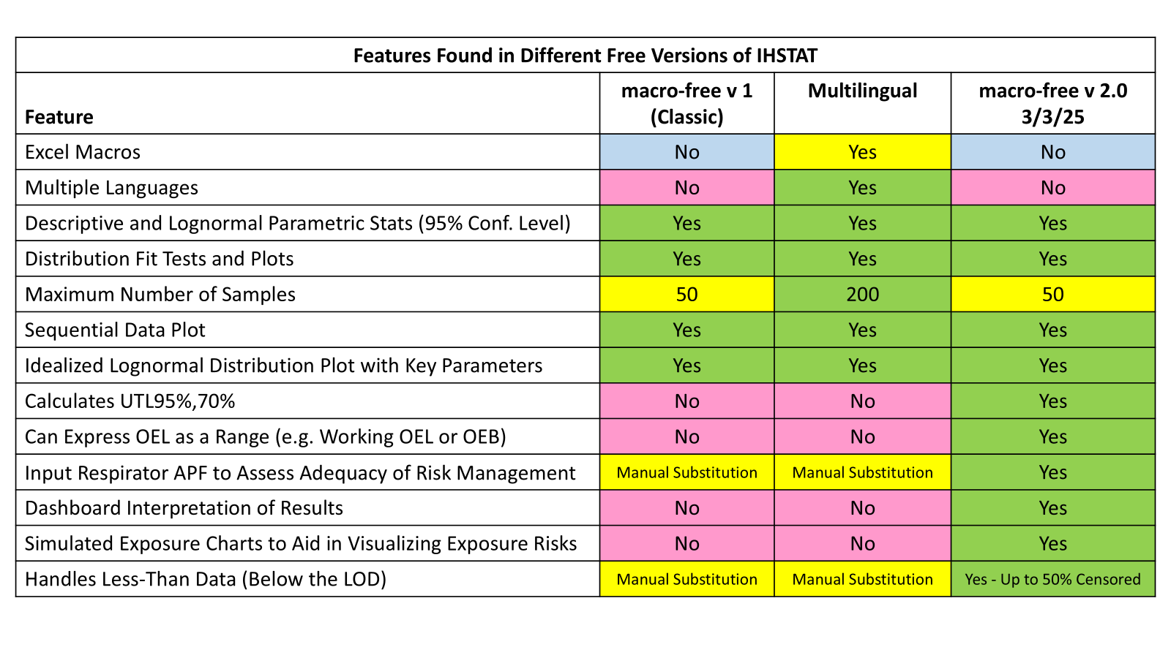
- IHSTAT Macrofree 1.0 (IHSTAT Classic)
Question | Answer
Why can I not install it on my laptop? | IHSTAT 1.0 is an Excel spreadsheet that does not contain macros. As long as you have Excel installed on your computer and your IT department does not restrict the spreadsheets that can be used, you should be able to use the spreadsheet.
How can I view all the data in a single moment without hiding other panels? | It was a design choice to keep all of the outputs on one Excel sheet. You can adjust the zoom when viewing the page to bring the entire sheet into view, but the outputs become very small.
Which result should I use? | We suggest taking the free training  "Making Accurate Exposure Risk Decisions". It includes training on the statistical analysis of monitoring data, The free online webinar is available here: https://www.aiha.org/education/elearning/online-courses/making-accurate-exposure-risk-decisions.  Good Reference: A Strategy for Assessing and Managing Occupational Exposures. 4th Ed. AIHA Press. 2015.
How do you interpret the "no < and no >" instruction in IHSTAT 1.0? | IHSTAT 1.0 will not accept “<” or “>” in the inputs. Handling of censored data must be done via a substitution method and the calculated substitutes for the LOD entered without “<” signs.  Consider switching to IHSTAT macrofree 2.0 which offers several approaches to automatically handling censored data.
How should I correctly enter my exposure data non-detects (e.g. <LOD) and does the tool automatically handle non-detects or censored data? | Censored data should always be included in the statistical analysis of the monitoring results. They should not be excluded nor should they be entered as the LOD. Instead, they should be included in the analysis using an appropriate censored data analysis method.  The classic IHSTAT 1.0 does not automatically handle censored data. The user must 1) choose a substitution method (e.g. LOD/2 or LOD/SQR ROOT(2)); 2) perform the calculation of the substitute value; and 3) enter the substitute value into the tool in place of the LOD.  IHSTAT macrofree 2.0 includes the ability to automatically handle censored data via LOD/2 or LOD/SQR ROOT(2) or BETA Substitution.  The best approach for handling censored data is to use one of the Bayesian statistical analysis tools (e.g. IHDA-AIHA, Expostats, IHSTAT_Bayes)  Good references for handing censored data include:  - Hewett, P. Appendix VIII: Analysis of Censored Data. A Strategy for Assessing and Managing Occupational Exposures. 4th Ed. AIHA Press. 2015.  - Huynh, Tran, Harrison Quick, Gurumurthy Ramachandran, Sudipto Banerjee, Mark Stenzel, Dale P Sandler, Lawrence S Engel, Richard K Kwok, Aaron Blair, and Patricia A Stewart. “A Comparison of the β-Substitution Method and a Bayesian Method for Analyzing Left-Censored Data.” The Annals of Occupational Hygiene 60, no. 1 (January 2016): 56–73.

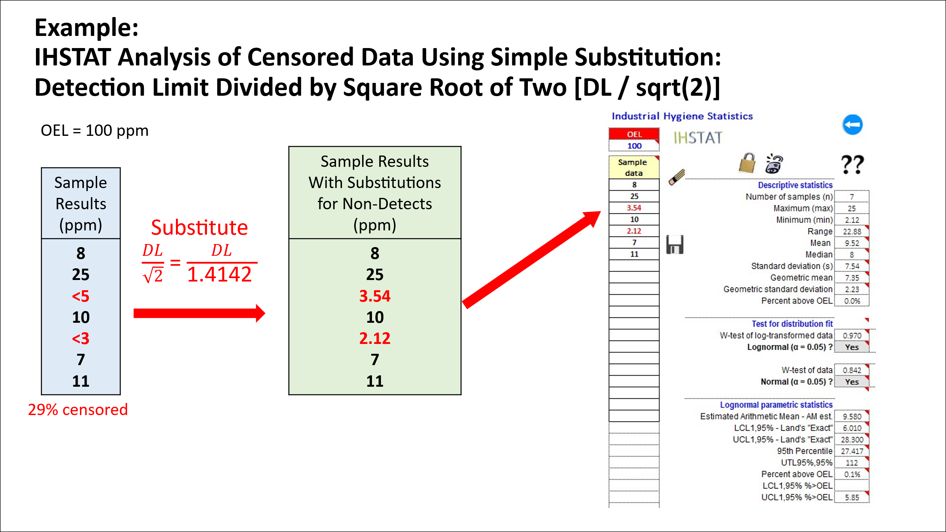

- IHSTAT macrofree v2.0
Question | Answer
What is the reason this tool is limited to a maximum of 50 results? | The tool is limited to a maximum of 50 sample results due to internal tables and algorithms used in the calculations that are limited to a maximum n of 50.
How can I analyze data sets with n>50? | You will need to use another tool if your n>50. We suggest IHSTAT Multilanguage (n=<200) or Expostats.
How do I download the tool as the link to version 2.0 led to a download for version 1.0? | You need to scroll down to the bottom of the page. The page includes a download section for IHSTAT 1.0 (top of page) and IHSTAT 2.0 (Bottom of page)  https://www.aiha.org/public-resources/healthierworkplaces/workplace-hazards/apps-and-tools-resource-center/aiha-risk-assessment-tools/ihstat-macro-free-version
Where can I get user videos of how to use the software? (AIHA improving exposure judgements, updated examples)? | None are available at this time
How do I store my data and the statistical analysis? | Simply do a “Save As” to store the spreadsheet with the data and analysis as a separate spreadsheet with a unique name.

- IHSTAT MultiLanguage
Question | Answer
How reliable are the statistical outputs from the tool when analyzing small data sets (e.g. less than 6 samples)? | All of the traditional frequentist versions of IHSTAT, including IHSTAT MultiLanguage, require at least three samples. Parameter estimates will be uncertain when based on low sample sizes and that uncertainty will be reflected in large values of the Upper Tolerance Limits (UTLs). Depending on the GSD and how close the SEG exposures are to the OEL, more samples may be needed to reach the desired confidence that the SEG 95th percentile is below the OEL.

- General Bayesian Statistics
Question | Answer
How do I explain Bayesian Decision Analysis (BDA) results to managers or non-technical audiences? | BDA charts are an extremely effective way to communicate intensity of exposure relative the OEL along with the uncertainty associated with the estimate. They depict the likelihood that the exposure profile 95th percentile is in each of the AIHA Exposure Control Categories (ECC). In addition, because the ECCs define appropriate follow-up control, they provide an easy-to-follow approach to defining appropriate exposure management activities (See Figure below).  For more information we suggest taking the free training webinar "Making Accurate Exposure Risk Decisions" available here: https://www.aiha.org/education/elearning/online-courses/making-accurate-exposure-risk-decisions.  A good reference is:  A Strategy for Assessing and Managing Occupational Exposures. 4th Ed. AIHA Press. 2015.

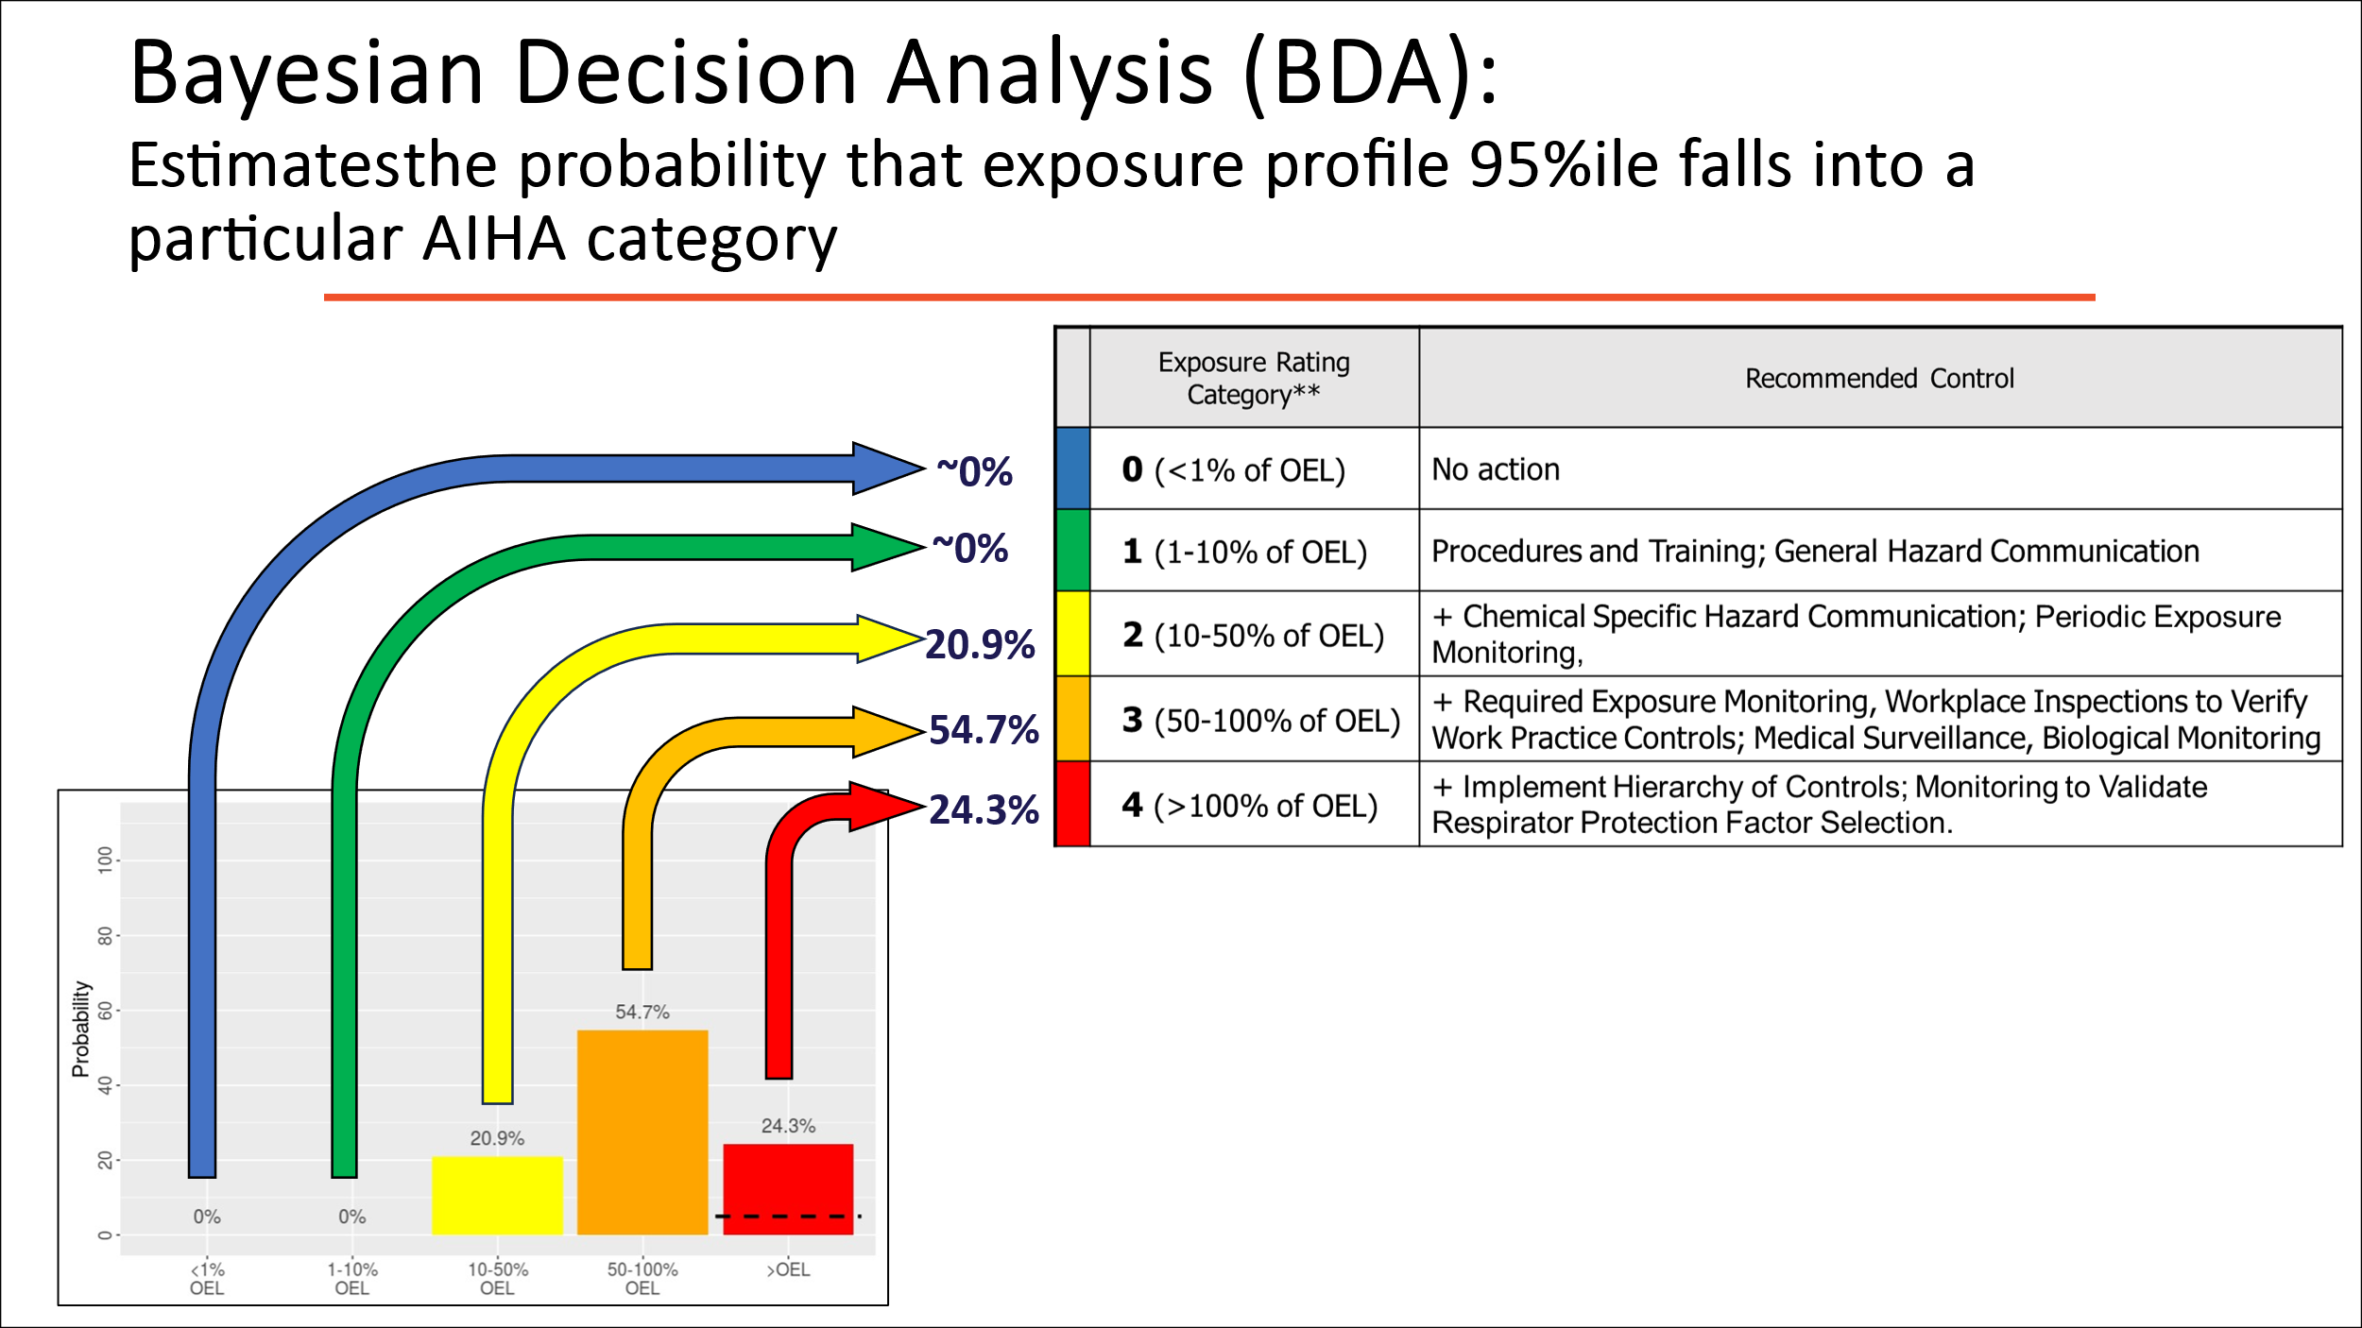

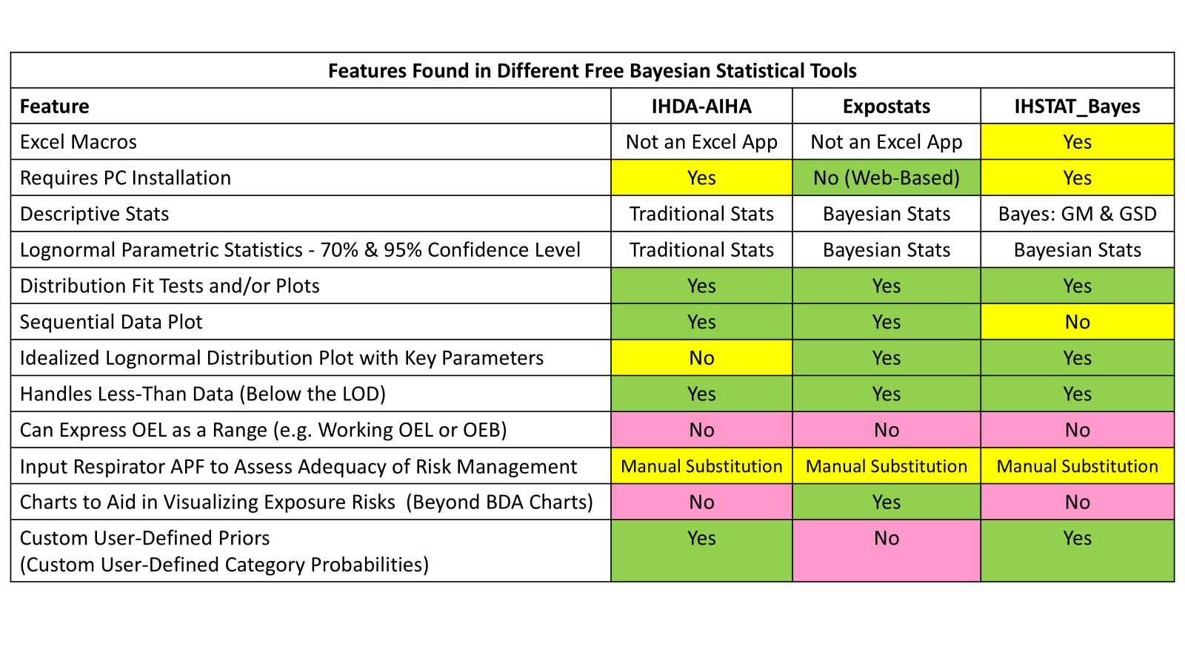

- IHDA-AIHA
Question | Answer
Can IHDA AIHA be used to analyze personal noise exposure data? | Noise data can be analyzed as long as the noise exposure is entered as percent dose rather than decibels.
Is it only accurate for the analysis of dust sampling results? | In addition to particulate exposure data, IHDA-AIHA can be used for the statistical analysis of gas and vapor exposure data as well as noise exposure data expressed as percent dose.
How do I use the program? | IHDA-AIHA has a very useful Help File.  Other good resources include:  - The free online webinar "Making Accurate Exposure Risk Decisions" available here: https://www.aiha.org/education/elearning/online-courses/making-accurate-exposure-risk-decisions  - Chapter 22: Bayesian Decision Analysis for Industrial Hygiene in A Strategy for Assessing and Managing Occupational Exposures. 4th Ed. AIHA Press. 2015.
Are there free IHDA-AIHA tools available for the regulators incorporating Bayesian? | While there are no restrictions on who can use IHDA-AIHA, the tool developer does ask that “If you are using IHDA-AIHA on behalf of your client or employer please show your appreciation to the AIHA and the author of this program by donating $100 USD to the AIHA scholarship fund for each installed copy of the IHDA-AIHA"  Expostats is a free tool for Bayesian statistical analysis that is also available to anyone  https://expostats.ca/site/en/tools.html
Why are data points limited to 25? | The tool developer set up the free version this way. If you need to analyze higher numbers of samples then you may buy the commercial version or use Expostats https://expostats.ca/site/en/tools.html
Highly variable SEGs close to the OEL may require more than 25 samples in order to be highly confident that the 95th percentile is less than the OEL. How do I analyze them? | For highly variable SEGs (e.g. GSD > 4), it is recommended that the sample data be examined for unintended sources of bias and that the SEG be examined to determine whether it has been defined appropriately or whether it should be split into two or more groups based on task differences, work practice differences, or other factors.  There are several free statistical analysis tools available for analyzing data sets with n>25. Expostats is one that performs Bayesian analysis. https://expostats.ca/site/en/tools.html
Is there a macro free version of IHDA-AIHA? | IHDA_AIHA is not an Excel spreadsheet with macros. It is a stand-alone program that does have to be installed on a computer. If that presents issues than consider using Expostats, a web-based Bayesian analysis tool, or conducting frequentist statistical analysis (rather than Bayesian) using one of the two macro-free versions of IHSTAT.
Are there user guides or instructions? | IHDA-AIHA has a very useful Help File  The FREE online AIHA webinar "Making Accurate Exposure Risk Decisions" includes a module dedicated to IHDA-AIHA. It is available here: https://www.aiha.org/education/elearning/online-courses/making-accurate-exposure-risk-decisions  Other good resources include:  - Chapter 22: Bayesian Decision Analysis for Industrial Hygiene in A Strategy for Assessing and Managing Occupational Exposures. 4th Ed. AIHA Press. 2015.  - Hewett, P., Logan, P., Mulhausen, J., Ramachandran, G., and Banerjee, S.: “Rating Exposure Control using Bayesian Decision Analysis”, Journal of Occupational and Environmental Hygiene, 3: 568–581, 2006
Where do you find IHDA-AIHA in order to download it? | Download IHDA-AIHA here: https://www.aiha.org/public-resources/healthierworkplaces/workplace-hazards/apps-and-tools-resource-center/aiha-risk-assessment-tools/ihda-aiha
How many samples are necessary to use this tool? | If necessary, Bayesian statistical analysis tools can analyze data sets as small as n=1. However, due to the potential for unknown bias in the samples, both AIHA and CEN recommend for an initial or baseline survey that three or more measurements be collected from a well-defined exposure group.  Good resources include:  - The IHDA-AIHA Help File  - The FREE online AIHA webinar "Making Accurate Exposure Risk Decisions" includes a module dedicated to IHDA-AIHA. It is available here: https://www.aiha.org/education/elearning/online-courses/making-accurate-exposure-risk-decisions.  - “Chapter 22: Bayesian Decision Analysis for Industrial Hygiene” in A Strategy for Assessing and Managing Occupational Exposures. 4th Ed. AIHA Press. 2015.  - "Appendix X: Sampling Strategy Design" in A Strategy for Assessing and Managing Occupational Exposures, 4th Edition. AIHA. 2015
How does one navigate through the tool? | IHDA-AIHA has a very useful Help File.  The FREE online AIHA webinar "Making Accurate Exposure Risk Decisions" includes a module dedicated to IHDA-AIHA. It is available here: https://www.aiha.org/education/elearning/online-courses/making-accurate-exposure-risk-decisions.

- Expostats
Question | Answer
How do you decide whether the goodness of fit justifies use of a method for lognormal data? | Sample data from a lognormal distribution will approximate a straight line when plotted in the Quantile-Quantile plot. Random deviations from a straight line are expected. However, significant deviations suggest that the data may have to be split into distinct subsets, or that some outliers must be investigated.
What is the Expostats prior and can it be changed? | At this time the prior in Expostats is fixed and cannot be changed. The GM is fixed between 2x10-9 x OEL and 5x108 x OEL and uniform on the logarithmic scale. The GSD is a lognormal distribution of ln(GSD) with GM = 0.84 and GSD = 1.87.  See Jérôme Lavoué, Lawrence Joseph, Peter Knott, Hugh Davies, France Labrèche, Frédéric Clerc, Gautier Mater, Tracy Kirkham, “Expostats: A Bayesian Toolkit to Aid the Interpretation of Occupational Exposure Measurements”, Annals of Work Exposures and Health, Volume 63, Issue 3, April 2019, Pages 267–279  Future plans for Expostats call for allowing user adjustable priors.
Do I need to transform my data to log scale before entering it in Expostats? | The free tools assume that the data entered are lognormally distributed. Chemical exposure data are typically lognormally distributed, so they do not need to be converted - simply enter the sample results "as is" in the same units as the OEL.  Noise data must be entered as percent dose, which is lognormally distributed, not as decibel levels, which are not lognormally distributed,
What is the difference between Tool 1 Extended and Tool 1 Express? | Tool 1 Express is a streamlined version of Tool 1 Extended. It includes fewer input options and outputs but is quicker to use. Calculated results are identical.
Can I install Expostats on my laptop? | No. This feature is currently not available.
What is the URL for the Expostats website? | Here it is: https://expostats.ca/site/en/tools.html
I am enjoying the new format. Why was it changed? | Continuous improvement. Glad you appreciate the changes!
How do you enter samples less than the detectable limit (i.e. <LOD)? | In Expostats one simply enters values less than the detection limit (i.e. censored data) using the “<” symbol followed by the LOD value (e.g. “<23” for a value that is less than a detection limit of 23).  Expostats also allows censored observations to be entered as intervals (e.g., [LOD–LOQ]), which is particularly useful for “detected but not quantified” results or when computing TWAs from multiple samples including one or several non-detects; representing such values as ranges preserves substantially more information than simple “<” notation whenever possible.
How do I interpret the output - especially the probability of exceeding the OEL? | Take the FREE online AIHA webinar "Making Accurate Exposure Risk Decisions" available here: https://www.aiha.org/education/elearning/online-courses/making-accurate-exposure-risk-decisions  Good references include:  - Jérôme Lavoué, Lawrence Joseph, Peter Knott, Hugh Davies, France Labrèche, Frédéric Clerc, Gautier Mater, Tracy Kirkham, “Expostats: A Bayesian Toolkit to Aid the Interpretation of Occupational Exposure Measurements”, Annals of Work Exposures and Health, Volume 63, Issue 3, April 2019, Pages 267–279  - A Strategy for Assessing and Managing Occupational Exposures. 4th Ed. AIHA Press. 2015.
How do you to use Expostats? | Take the FREE online AIHA webinar "Making Accurate Exposure Risk Decisions" available here: https://www.aiha.org/education/elearning/online-courses/making-accurate-exposure-risk-decisions.  It includes a module dedicated to Expostats.  A good reference is: Jérôme Lavoué, Lawrence Joseph, Peter Knott, Hugh Davies, France Labrèche, Frédéric Clerc, Gautier Mater, Tracy Kirkham, “Expostats: A Bayesian Toolkit to Aid the Interpretation of Occupational Exposure Measurements”, Annals of Work Exposures and Health, Volume 63, Issue 3, April 2019, Pages 267–279
What should the Expostats parameters be set to in order to obtain the 95th percentile with 70% confidence? | Both Expostats Tool1 Express and Extended versions automatically provide the 70% and 95% upper confidence limit on the 95th percentile. Additionally, Tool1 Express provides a 90% confidence interval, and Tool1 Extended a confidence interval with user selected confidence level.  For users preferring probabilistic results (i.e. risk of overexposure, or chances that the true 95th percentile is above the OEL), Tool1 Express presents this probability with a 3 color scheme as found in the free AIHA exposure decision videos (red/unacceptable if >30%, yellow/tolerable if [5-30%], and green/acceptable if <5%). Tool1 Extended proposes a red/green dichotomy between unacceptable and acceptable with the threshold (overexposure risk threshold) being user selected (default 30%).
How do you export the data/results? | You'll need to use cut and paste for the text. You can copy the figures by right clicking on them. The Windows screenshot tools, which now allows to select parts of the screen, is also very useful.
What does it do, how does it work, and how do I interpret the results? | Take the FREE online AIHA webinar "Making Accurate Exposure Risk Decisions" available here: https://www.aiha.org/education/elearning/online-courses/making-accurate-exposure-risk-decisions.  It includes a module dedicated to Expostats.  A good reference is: Jérôme Lavoué, Lawrence Joseph, Peter Knott, Hugh Davies, France Labrèche, Frédéric Clerc, Gautier Mater, Tracy Kirkham, “Expostats: A Bayesian Toolkit to Aid the Interpretation of Occupational Exposure Measurements”, Annals of Work Exposures and Health, Volume 63, Issue 3, April 2019, Pages 267–279
There is an assumption that noise data, when expressed as dose, follows the same lognormal distribution as chemical samples, but the underlying universe of GMs and GSDs is based on inhalation exposure data, not noise data. Are the underlying datasets informing the universe of describing GMs and GSDs appropriate for analyzing noise data? | We are not aware of an extensive study of the distribution of GM and GSD for noise dose. Our experience is that the GSDs for noise dose exposures are not too dissimilar from those seen with chemical samples. However, as is stated in the webinar training: “always check the GSD when doing the analysis” to ensure that it is compatible with the universe of GSDs included in the universe (i.e. parameter space).  If concerned, consider using IHDA-AIHA with the universe (parameter space) GSD and GM set very large so that even extreme values would be included in the analysis.

- IHSTAT_Bayes
Question | Answer
I am very new to exposure analysis. My main question is: What is it, how to use it, and how do I interpret the information it gives? | We suggest taking the free training  "Making Accurate Exposure Risk Decisions". In addition to training on statistical analysis of monitoring data, it includes a module on IHSTAT_Bayes. The free online webinar is available here: https://www.aiha.org/education/elearning/online-courses/making-accurate-exposure-risk-decisions.  Good References include:  - A Strategy for Assessing and Managing Occupational Exposures. 4th Ed. AIHA Press. 2015.  - Hewett, P., Logan, P., Mulhausen, J., Ramachandran, G., and Banerjee, S.: “Rating Exposure Control using Bayesian Decision Analysis”, Journal of Occupational and Environmental Hygiene, 3: 568–581, 2006  - Jérôme Lavoué, Lawrence Joseph, Peter Knott, Hugh Davies, France Labrèche, Frédéric Clerc, Gautier Mater, Tracy Kirkham, “Expostats: A Bayesian Toolkit to Aid the Interpretation of Occupational Exposure Measurements”, Annals of Work Exposures and Health, Volume 63, Issue 3, April 2019, Pages 267–279
How do I get the tool to calculate the 70% upper confidence limit for the 95th percentile as required for EN689? | The standard analysis results from IHSTAT_Bayes include point estimates as well as the UCL70% and the UCL95% for 95th percentile, exceedance fraction, and arithmetic mean of the exposure profile. See the figure below from IHSTAT_Bayes.

