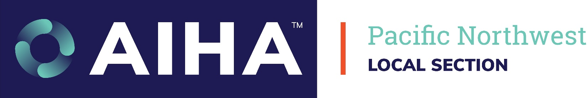
Subject: Request for Approval to Attend: Northwest Occupational Health Conference (NOHC) 2026
Dear [Manager's Name],
I am writing to request approval to attend the Northwest Occupational Health Conference (NOHC) 2026, taking place October 21–23, 2026, in Bothell, WA.
Jointly presented by the Pacific Northwest Section of the American Industrial Hygiene Association (PNS-AIHA) and the Northwest Association of Occupational and Environmental Medicine (NAOEM), NOHC is the region’s premier gathering for occupational safety, industrial hygiene, and environmental health professionals.
Direct Return on Investment (ROI) for [Company/Organization Name]
Attending this conference is a high-value investment that will yield direct returns for our organization through risk reduction, operational efficiency, and regulatory readiness:
Actionable Technical Knowledge: Short course and technical tracks focused on industrial hygiene, toxicology, and occupational medicine will give me immediate tools to optimize our internal safety programs and minimize workplace hazard exposures.
Cost Avoidance & Risk Mitigation: Staying up to date on emerging regulatory trends, research, and technical safety standards helps protect our workforce while reducing the risk of costly incidents, workers' compensation claims, and compliance penalties.
Industry Benchmarking: Networking with regional safety directors, EHS experts, physicians, and risk managers will allow me to benchmark our current EHS strategies against proven industry best practices.
Estimated Expense Breakdown:
Registration Fee: $[Amount]
AIHA or NAOEM Member -
Full Conference: Short Course (W) + General Session (Th/F) = $550
Short Course Only (W) = $250
General Session Only (Th/F) = $350
Non-Member –
Full Conference: Short Course (W) + General Session (Th/F) = $650
Short Course Only (W) = $350
General Session Only (Th/F) = $400
Student –
Full Conference: Short Course (W) + General Session (Th/F) = $50
Short Course Only (W) = $25
General Session Only (Th/F) = $25
PNS-AIHA Dues = $50
Travel / Mileage: $[Amount]
Lodging: $[Amount]
McMenamin’s Room Block $169/night; Discount Code: 2610NWOCCU
Meals & Incidentals: $[Amount]
Included: Breakfast (W-F) and lunch (W/T)
Total Investment: $[Total Amount]
I am confident that the practical insights, compliance strategies, and professional training I gain at NOHC 2026 will deliver a clear return that far exceeds the cost of attendance.
Thank you for your consideration. I look forward to discussing how this conference aligns with our current priorities.
Sincerely,
[Your Name]
[Your Title]
[Your Department/Organization]

