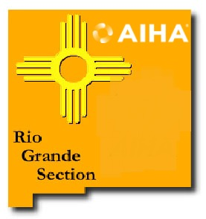
AMERICAN INDUSTRIAL HYGIENE ASSOCIATION
Rio Grande Section Membership Information

Name: Date:

Employer: Job Title:

Contact & Mailing Information (please check where you prefer to be contacted)*: Home Work

E-mail:

Phone: Cell:

*We respect your privacy and will use your information only for AIHA purposes.

AIHA National Member: Yes (Member # since ) Please list any AIHA National Committees that you serve on:

(Note: RGAIHA encourages AIHA National Membership to participate in Local Section Activities. All elected positions require good standing as an AIHA National Member. If you’re not a National Member, can we interest you in becoming one?)

Tell us about any specific topics that you would like to see covered in meetings or conferences:

Please return this form with your check for $35.00 (check # ) for calendar year 2026 to:

Andrew Peterson
RGAIHA Treasurer
1852 Sun Mountain Drive
Santa Fe, NM, 87505

Or email to riograndeaiha@gmail.com​ with “Membership” in the subject line and pay online at https://squareup.com/store/rio-grande-american-industrial-hygiene-association

